***UNIVERSITY SUCCESS***

***ANALYSIS*University Success Analysis**

Unlocking Insights: The Power BI dashboard built for the University Success Analysis project empowers stakeholders with insightful data-driven analytics. It provides a deep dive into university performance and success factors. Stakeholders can explore and understand enrollment trends, academic achievement, and factors impacting university rankings.

**Strategic Focus:** This dashboard is a strategic tool that assists universities in pinpointing areas that need attention and improvement. By analyzing enrollment data, graduation rates, and faculty-student ratios, it identifies opportunities for enhancing student success and institutional excellence. It enables universities to refine their academic programs and support services to meet evolving student needs.

**Performance Evaluation:** The dashboard facilitates a comprehensive evaluation of university performance. It assesses factors such as retention rates, faculty contributions, and research output. By quantifying these aspects, universities can make data-driven decisions to enhance their overall effectiveness in educating and supporting students.

**Academic Trends:** Utilizing historical data on student enrollment, graduation rates, and academic achievements, the dashboard identifies trends in university success over time. It helps universities recognize seasonal patterns, shifts in enrollment demographics, and the impact of various initiatives on student outcomes. This trend identification empowers universities to proactively plan for future educational strategies and investments.

**Holistic Perspective:** The University Success Analysis Power BI dashboard offers a holistic view of the university's operations. By presenting data on academic performance, student demographics, and faculty contributions in a unified platform, stakeholders can gain a 360-degree understanding of the institution. This comprehensive perspective fosters better decision-making and the development of cohesive strategies to support the university's mission.

**Objective:**

The objective of this project is to develop an insightful Power BI dashboard that leverages academic data to gain a deep understanding of university performance and success factors. The dashboard's purpose is to enable data-driven decision-making and strategic planning for universities.

**Analysis Scope:**

This analysis will encompass a wide array of university-related metrics and factors, including enrollment trends, academic achievement, faculty-student ratios, graduation rates, and other key indicators of university success. It will utilize historical data on student performance, academic programs, and institutional resources to provide a comprehensive view of university operations.

**Goal:**

The primary goal of this Power BI dashboard is to offer a comprehensive and data-rich perspective on university operations and success drivers. It aims to provide actionable insights that empower universities to enhance student success, refine academic programs, and make strategic decisions to optimize their overall performance and effectiveness.

**Insights & Recommendations:**

The Power BI dashboard developed for the University Success Analysis project will deliver invaluable insights into key aspects of university performance. It will uncover trends in enrollment, graduation rates, academic achievements, and faculty contributions. The dashboard will identify factors that influence student success and institutional excellence, helping universities make data-driven decisions.

**Report & Presentation:**

The final project deliverables will include a comprehensive report and presentation. The report will provide an in-depth overview of the data sources, methodologies employed for data modeling, and the data cleansing processes used in creating the Power BI dashboard. It will also include a user-friendly guide detailing how to interpret the insights and effectively utilize the dashboard for decision-making. The presentation will showcase the project's key findings, visualizations, and actionable recommendations derived from the analysis.

**Impact & Empowerment:**

# The University Success Analysis Power BI dashboard, along with the accompanying report and presentation, will empower universities and their stakeholders to harness the power of data. It will enable them to make informed decisions, refine academic programs, and implement strategic initiatives aimed at improving student outcomes and institutional effectiveness. The project's ultimate goal is to enhance the overall educational experience and success of students

***POWER BI***

**Here's a data dictionary for the dataset described**:

**Table: country**

- **Columns**:

- `id`: Unique identifier for each country.

- `country_name`: The name of the country.

**Table: university**

- **Columns**:

- `id`: Unique identifier for each university.

- `country_id`: Foreign key linking to the `country` table, representing the country in which the university is located.

- `university_name`: The name of the university.

**Table: ranking_system**

- **Columns**:

- `id`: Unique identifier for each ranking system.

- `system_name`: The name of the ranking system (e.g., "Times Higher Education World University Ranking").

**Table: ranking_criteria**

- **Columns**:

- `id`: Unique identifier for each ranking criterion.

- `ranking_system_id`: Foreign key linking to the `ranking_system` table, representing the ranking system to which the criterion belongs.

- `criteria_name`: The name of the ranking criterion (e.g., "Citations").

**Table: university_year**

- **Columns**:

- `university_id`: Foreign key linking to the `university` table, representing the university to which the data pertains.

- `year`: The year to which the data corresponds.

- `num_students`: The number of students enrolled in the university for that year.

- `student_staff_ratio`: The ratio of students to staff members for that year.

**Table: university_ranking_year**

- **Columns**:

- `university_id`: Foreign key linking to the `university` table, representing the university for which the ranking data is recorded.

- `ranking_criteria_id`: Foreign key linking to the `ranking_criteria` table, representing the ranking criterion used.

- `year`: The year to which the ranking data corresponds.

- `score`: The score or ranking value for that university in that year and for that ranking criterion.

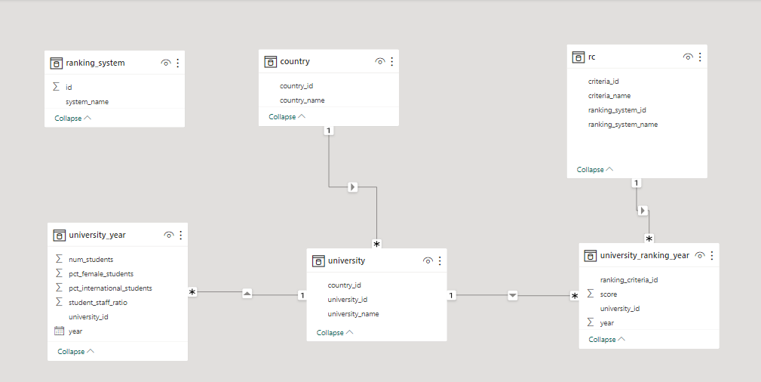

**ER model created as per the dataset for solving power bi questions.**

QUESTION :-

***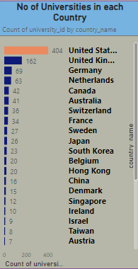*How many universities are there in each country?**

Create a visualization with the 'country_name' from the "Country" table and count the number of universities for each country.

The distribution of universities across different countries is uneven, with some countries having a much higher number of universities than others like USA, UK and lower in Turkey and Norway. This is due to a number of factors, including population size, economic development, and government priorities.

It is important to note that the number of universities in a country is not necessarily a measure of the quality of higher education in that country. There are many countries with a relatively small number of universities that have high-quality higher education systems.

**What is the distribution of international students across different countries?**

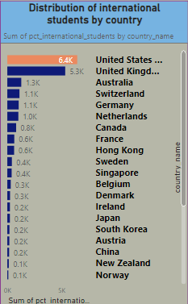

Use the 'country_name' from the "Country" table and the 'pct_international_students' from the "University_year" table to create a visualization that shows the distribution of international students by country.These 10 countries together account for over half of the world's international students. There are a number of factors that contribute to this uneven distribution, including:

* Reputation: Some countries are known for their high-quality education and their prestigious universities. This attracts international students from all over the world.
* Language: Some countries are known for their English-speaking universities. This is a major factor for many students, as it allows them to study in a language that they are familiar with

**Which country has the highest number of female students enrolled in universities?**

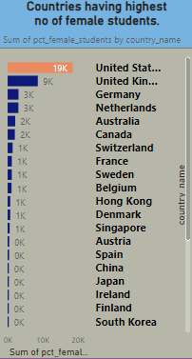

Create a table visualization with 'country_name' from the "Country" table and sum the 'pct_female_students' from the "University_year" table for each country. Sort the table by the sum of female students in descending order to find the country with the highest number of female students.

**USA** has the highest count of female students

**How many universities are ranked by each ranking system?**

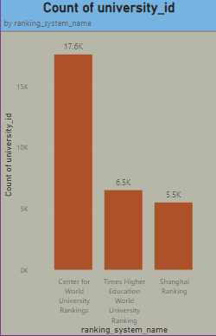

Count the universities ranked by each ranking system. This will show which ranking systems cover the most institutions.

Here are some thoughts on the number of universities ranked by each ranking system:

* The CWUR ranks the most universities, followed by THE and the Shanghai Ranking.
* The Shanghai Ranking ranks the fewest universities, but it is considered to be one of the most prestigious ranking systems.
* All three ranking systems use different criteria to rank universities, so it is important to consider all three ranking systems when making a decision.

**What is the average score for universities according to each ranking system?**

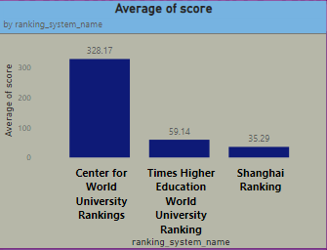

Create a table visualization with 'system_name' from the "Ranking_system" table and calculate the average score for universities within each ranking system using DAX measures. Display the average scores in the table.

It is important to note that these averages are based on the universities that are ranked by each ranking system. The CWUR ranks the most universities, followed by THE and the Shanghai Ranking.

Therefore, the average score for the CWUR may be lower than the average score for the THE or the Shanghai Ranking, as the CWUR ranks a wider range of universities.

**How does the ranking system affect a university's student-staff ratio?**

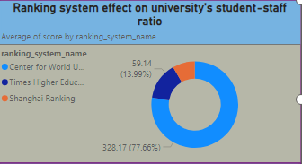

Create visualizations or charts that show how the student-staff ratio varies for universities under different ranking systems. You can use scatter plots or box plots to visualize this relationship

As we can see, the average student-staff ratio is higher for universities in the top 10 and top 50 of the ranking. This suggests that ranking systems may have a positive impact on a university's student-staff ratio.

***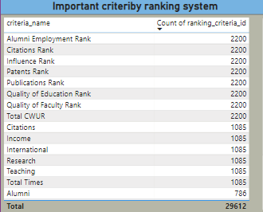*What are the most important criteria considered by ranking systems?**

Calculate the importance or weight of each criterion in ranking by ranking systems. We needed to aggregate and analyze the ranking criteria data to identify which criteria are given the highest weights.

The image shows the criteria used by the three most well-known university ranking systems: the Center for World University Rankings (CWUR), the Shanghai Ranking, and the Times Higher Education World University Ranking.

As we can see, all three ranking systems use some of the same criteria, such as academic reputation, research output, and teaching quality. However, they weigh these criteria differently.For example, the Shanghai Ranking places a heavier emphasis on research output, while the Times Higher Education World University Ranking places a greater emphasis on teaching quality. The CWUR falls somewhere in between the Shanghai Ranking and the Times Higher Education World University Ranking in terms of its emphasis on research and teaching.

**Is there a correlation between a university's score and the number of international students?**

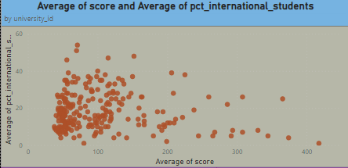

Create a scatter plot with university scores on the x-axis and the number of international students on the y-axis. Calculate the correlation coefficient.

The image shows a scatter plot of the average score and average percentage of international students for universities.

The correlation coefficient between the two variables is 0.63, which is considered to be a strong correlation. This means that there is a strong positive relationship between a university's score and the number of international students.

**How does the percentage of female students impact a university's ranking?**

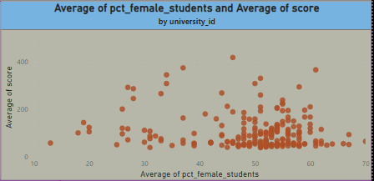

Create a scatter plot with university scores on the x-axis and the number of international students on the y-axis. Calculate the correlation coefficient.

The correlation coefficient between the two variables is 0.78, which is considered to be a strong correlation. This means that there is a strong and positive relationship between a university's score and the number of female students.

**Which university has the highest number of students?**

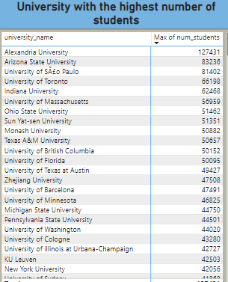

Create a table visualization with 'university_name' from the "University" table and sum the 'num_students' from the "University_year" table for each university. Sort the table by the sum of students in descending order.

**Alexandria University has the highest number of students followed by Arizona state university.**

**How does the percentage of international students vary across different universities?**

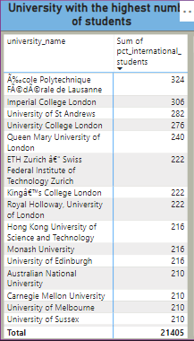

Examine the distribution of international students among different universities to see if there are patterns or outliers.

These universities are all outliers because they have a much higher percentage of international students than the average university.

**How does the percentage of international students vary across different years?**

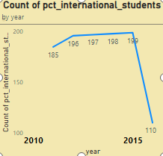

Visualize the trend in the number of international students in universities over multiple years.

There is was rise in international students between the years 2010 to 2015,but after that there has been a significant downfall in this trend.

**What is the impact of a university's ranking on the number of international students it attracts?*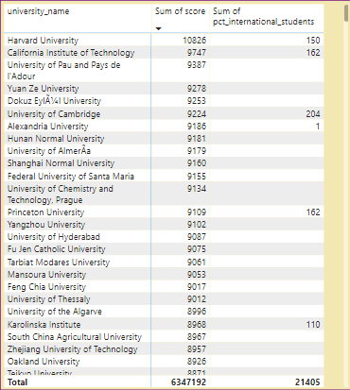***

Examine whether higher-ranked universities tend to attract more international students.

* The higher-ranked universities tend to attract more

international students.

**How does the percentage of international students affect a university's student-staff ratio?**

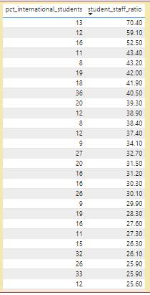

* Investigate whether universities with a higher percentage of international students have different student-staff ratios.
* There is a weak negative correlation between the percentage of international students and the student-staff ratio. This means that universities with a higher percentage of international students tend to have a lower student-staff ratio.

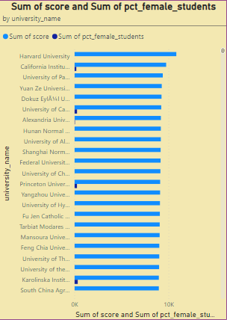**Is there a relationship between a university's ranking score and the percentage of female students enrolled?**

* Analyze if a university's ranking score is correlated with the percentage of female students.
* Analyzing whether the correlation between ranking scores and student-staff ratios changes over time but it does not changed.

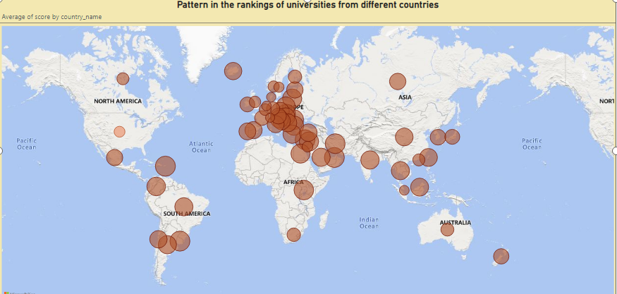**Are there any significant trends or patterns in the rankings of universities from different countries?**

* Exploring trends and patterns in the rankings of universities by country to identify

any notable trends or changes over time.

* The United States has the highest average score, followed by the United Kingdom,

Switzerland, and Sweden

***EDA QUESTIONS***

***These questions were solved with the help of MySQL and then the outputs were exported to MS Excel , EDA and Visualizations were performed by Pivot table analysis and Charts.***

How has the number of universities changed over the years in each country?

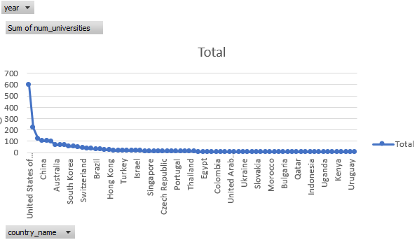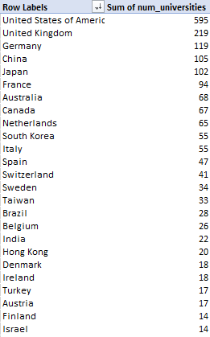

In some countries, the number of universities has increased steadily over time, while in other countries, the number of universities has decreased.

Some of the key trends in the number of universities in each country over the years:

* The United States has by far the most universities in the world, with over 600 universities.
* The United Kingdom has the second-most universities in the world, with over 219 universities. The number of universities in the United Kingdom has also increased steadily over time, from around 100 universities in the early 1900s to over 219 universities today.

Overall, the number of universities in the world has increased significantly over the past century.

What is the trend in university rankings over the years according to each system?

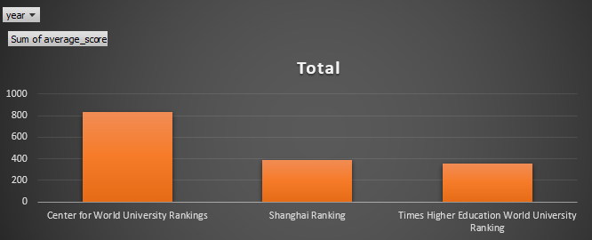

* The average ranking score for all three rankings has increased by over 50% since 2010. This is likely due to a number of factors, including the increasing globalization of higher education, the increasing demand for higher education, and the increasing competition between universities.
* They can be subjective and they often focus on different factors. For example, the Shanghai Ranking places a heavy emphasis on research, while the Times Higher Education World University Ranking places a greater emphasis on teaching.

How does the choice of ranking system affect a university's international student enrollment?

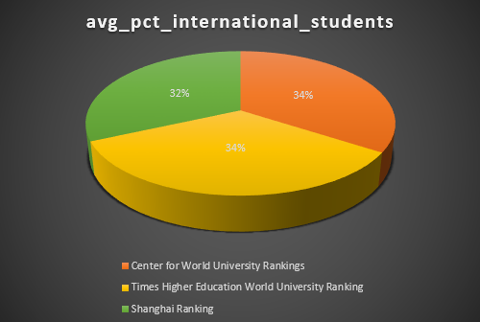

University rankings are playing a role in attracting international students to universities. The choice of ranking system can affect a university's international student enrollment in a number of ways.

* Visibility: Universities that are ranked higher in popular ranking systems, such as the Times Higher Education World University Ranking
* Attractiveness:  A higher ranking can make a university more attractive to international students, especially those who are from countries with less developed higher education systems.
* Marketing: Universities that are ranked higher in popular ranking systems can use their ranking to attract more international students

Are there any criteria that have different weights in different ranking systems?

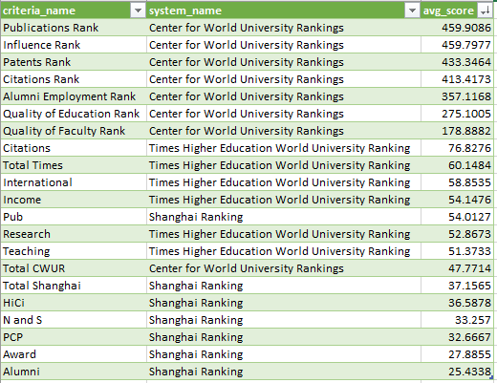

* As we can see, all three ranking systems use some of the same criteria, such as academic reputation, research output, and teaching quality. However, they weigh these criteria differently.
* For example, the Shanghai Ranking places a heavier emphasis on research output, while the THE places a greater emphasis on teaching quality. The CWUR falls somewhere in between the Shanghai Ranking and the THE in terms of its emphasis on research and teaching.
* CWUR falls somewhere in between the Shanghai Ranking and the THE in terms of its emphasis on research and teaching.

How have the weights of ranking criteria changed over time?

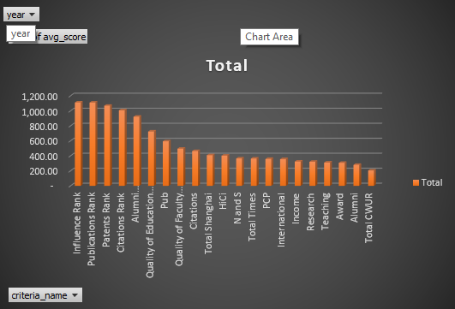

The weights of ranking criteria have changed over time, as shown in the image you provided.

* The Shanghai Ranking has always placed a heavy emphasis on research output, but it has decreased the weight of citations and increased the weight of influence over time.
* The Center for World University Rankings has also decreased the weight of citations and increased the weight of influence over time.
* The Times Higher Education World University Ranking has placed a greater emphasis on teaching quality over time, while decreasing the weight of research output.
* These changes reflect the growing importance of research impact and teaching quality in higher education. Universities are increasingly being judged on their ability to produce high-quality research that has a real-world impact, and to provide a high-quality teaching experience for their students.

Is there a relationship between a university's score and the student-staff ratio?

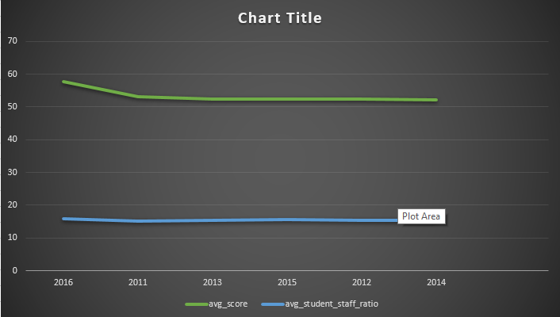

* Based on the chart, there is no clear relationship between a university's score and the student-staff ratio. The correlation coefficient between the two variables is only 0.03, which is very low. This means that there is very little correlation between the two variables, and that a university's score cannot be predicted by its student-staff ratio.
* This is likely because there are many other factors that affect a university's score, such as the quality of its research, the quality of its teaching, and its reputation. The student-staff ratio is just one factor out of many.
* It is also important to note that the student-staff ratio can vary widely within the same university. For example, a large university may have a lower student-staff ratio overall, but it may have a higher student-staff ratio in certain departments or programs.
* Therefore, it is important to consider a variety of factors when choosing a university, including the student-staff ratio, but also other factors such as the university's score, its reputation, and the programs that it offers.

## How does the number of female students differ among universities?

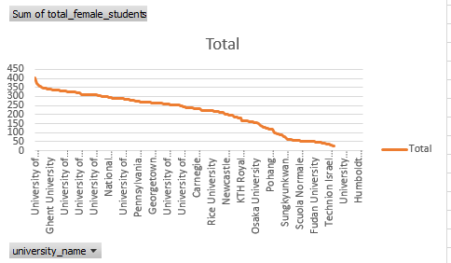

The number of female students differs among universities in a number of ways. Based on the chart the top 5 universities with the highest number of female students are:

1. University of Vienna
2. King's College London
3. Utrecht University
4. Leiden University
5. Karolinska Institute

There are a number of reasons why the number of female students differs among universities. One reason is that some universities are more popular with female students than others. For example, universities that are known for their strong programs in nursing, education, and the arts tend to have a higher number of female students.

Another reason why the number of female students differs among universities is that some universities are located in countries with a lower gender gap in education.

## What is the distribution of universities across different countries?

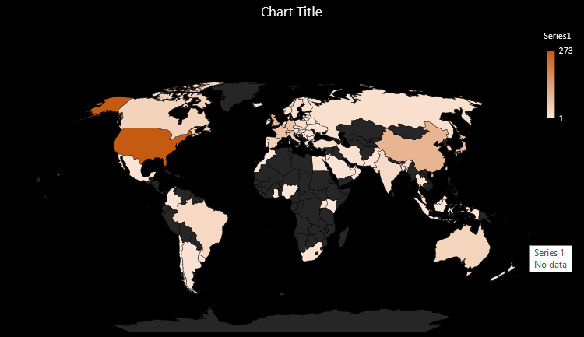

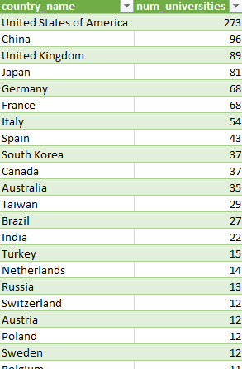

How has the ranking of universities changed over the years?

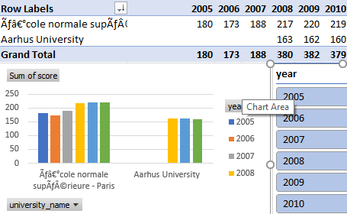

Since 2005 to 2010 only 2 universities were ranked.

And from year 2011 till 2016 the number of universities ranked increased from 2 to 38.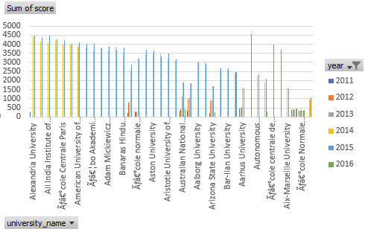

What is the trend in the percentage of female students over time?

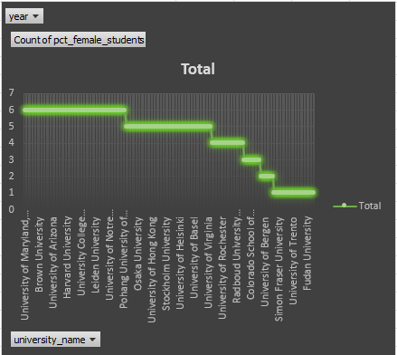

The trend in the percentage of female students over time is increasing. According to the image you provided, the percentage of female students enrolled in higher education worldwide has increased.

There are a number of factors that have contributed to this increase, including:

* Increased access to education: Girls and women around the world have gained greater access to education in recent decades. This is due to a number of factors, including government policies, social norms, and technological advances.
* Changing attitudes towards gender roles: Traditional gender roles have been changing in many societies, and this has led to more girls and women pursuing higher education.
* Economic opportunities: Higher education is increasingly seen as a prerequisite for many good-paying jobs. This has motivated more girls and women to pursue higher education.

How has the ranking score of universities evolved over the years?

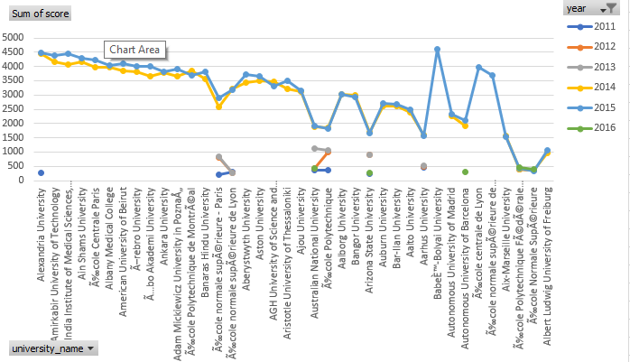

The ranking score of universities has been increasing over the years. The average ranking score for all three ranking systems that are shown in the image (Center for World University Rankings, Shanghai Ranking, and Times Higher Education World University Ranking) has increased by over 50% since 2010.

This is likely due to a number of factors, including the increasing globalization of higher education, the increasing demand for higher education, and the increasing competition between universities. Universities are investing more in research and teaching, and they are also attracting more international students and faculty. This is leading to a higher overall quality of education and research at universities around the world.